Jordan Funeral Home, Inc.
PO Box 46
Monticello, Georgia 31064
706-468-6303
Fax: 706-468-2205
Website: www.jordanfuneralhomemonticello.com

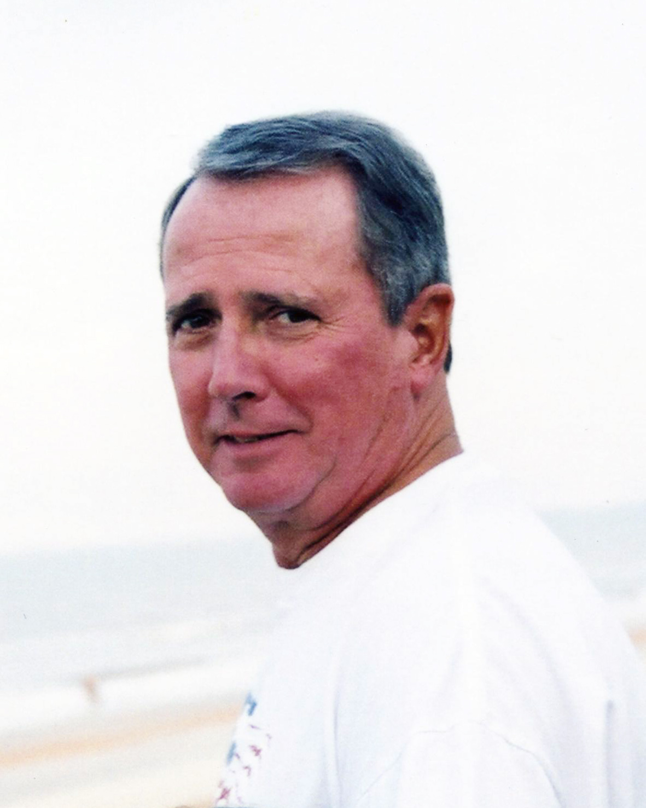

Jerry Dean Yancey, age 73, of Monticello, passed away Thursday, February 27, 2014, at Piedmont Hospital in Atlanta.

Jerry Yancey was born and raised in Atlanta, Georgia. His parents were the late George Plummer Yancey and Minnie Louise Leftwich Yancey. He was a graduate of the University of Georgia Pharmacy School.

Before retirement, Jerry was the Senior Manager of the Southeastern Region with Bristol-Myers Squibb and lived in Charlotte, North Carolina, Dunwoody, Georgia, and Raleigh, North Carolina. After retirement, they moved to Monticello twenty years ago and worked as a part-time pharmacist at the Monticello Drugs.

He was an active member of the Monticello Baptist Church. Mr. Yancey has been an active member and leader at Monticello Baptist Church serving in many ministry and missions positions. He has served as chairman of Deacons, coordinated Benevolence and was instrumental in the organization and leadership of the church’s Mission and Ministry Committee. He was also instrumental in the Summer Monticello Community Mission Outreach “Mission Mania.”

He was a huge Georgia Bulldog fan and enjoyed attending the games. He also enjoyed working on his cattle farm and riding his grandchildren on the tractor and gator.

He is survived by his loving wife of fifty-two years and high school sweetheart, Guin Parrish Yancey of Monticello; sons and daughters-in-law, Michael Dean and Carol Yancey of Dunwoody, Christopher Allen and Jeannie Yancey of Athens, and Tyler Parrish and Candice Yancey of Monticello; grandchildren, David, Jennifer, Heather, Madison, Daniel, Layne, Andrew, and Nathaniel Yancey; sister, Betty Dial of Stockbridge; and numerous nieces and nephews.

A private family graveside service will be held at 3:00 P.M., Saturday, March 1, 2014, at Westview Cemetery in Atlanta.

A Celebration of Life service will be held at 4:00 P.M., Sunday, March 2, 2014, at the Monticello Baptist Church in Monticello. Dr. Robert Whitmire will officiate.

The family suggests in lieu of flowers donations be made to the Monticello Baptist Church, 334 W. Greene Street, Monticello, Georgia 31064 or Tyler’s Mission Ministry Connect 3, 482 Liberty Drive, Monticello, Georgia 31064 (connect3bridge.com).

Jordan Funeral Home is in charge of arrangements.

