**Jordan Funeral Home, Inc.**

**PO Box 46**

**Monticello, Georgia 31064**

**706-468-6303**

**Fax: 706-468-2205**

**Email: jordanfh@bellsouth.net**

**Stacey Goolsby Standifer**October 27th,1938 - February 8th, 2024

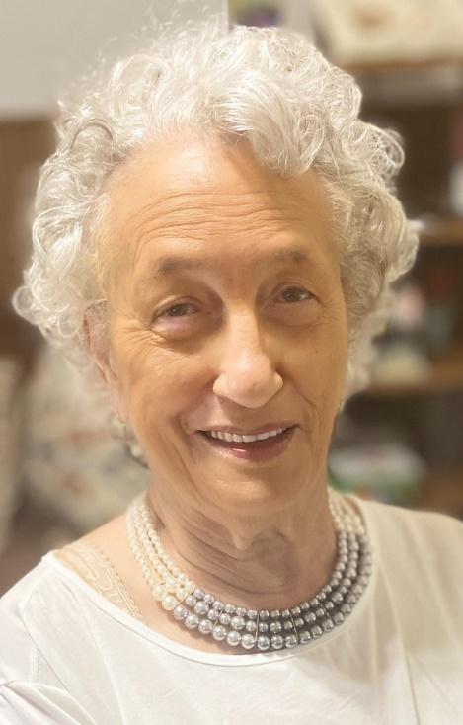Stacey Goolsby Standifer was born October 27th, 1938 in Hillsboro, GA to the late Lettie and Samuel McMichael, Sr. She was nurtured by her parents and grandparents, the late Johnnie and Geraldine Goolsby.

Stacey received her education from Jasper County Training School and graduated in the Class of 1957. While attending, she played on the basketball team and was homecoming queen her senior year. She joined Piney Grove Baptist Church at a very young age and later joined Springfield Missionary Baptist Church where she was a faithful and loyal member serving on the Mother’s Board and as church secretary.

Stacey was married to the late Willie Cleve Standifer on October 27th, 1957. Their union created five children.

Her working career started at The Monticello Sewing Room and Washington Park Elementary School. This was followed by a career as a bank teller at The Bank of Monticello, beginning in 1979 and ending in retirement twenty-seven years later.

She was an active member of the Bonner Street Civic Organization, Jasper County Board of Education, and the Hurricane Booster Club. She was also a dedicated servant to the community, mentoring in the school system and to countless people that came across her path. Stacey also volunteered as a poll worker during elections.

One of Stacey’s favorite pastimes were cooking for her loved ones. Those who had the good fortune to eat her collard greens or taste her delicious cakes, always went backfor more. She loved sitting on her porch enjoying the sunshine, joy riding and watching sports. Her absolute favorite teams were the Atlanta Hawks, Atlanta Braves, Atlanta Falcons and Georgia Tech. She loved flowers, enjoyed tending to her yard and took pride in making sure it looked well-manicured and welcoming. Stacey was an excellent seamstress and early on, she sewed most of her own clothes.

Anyone who knew Stacey knew that her door was always open, to everyone and their conversations were safe with her. She would let you know if you were right or wrong; however, it was done with love. She was a straight shooter with much sassiness who loved to laugh, even at herself. She never met a stranger and truly loved everyone but more importantly, Stacey Loved God.

In addition to her husband, Stacey was preceded in death by her brothers Johnnie and Eddie McMichael; her sister Jerrie Knight-Huewitt; her in-laws Charles Standifer, Richard Standifer, Robert Standifer, Ernest Standifer, Lois Standifer, Catherine Standifer and Anita Campbell.

Memories of Stacey will be cherished by her devoted children: daughters Sharon Standifer of Lithonia and Michelle Standifer-Kelley (John) of Peachtree City; sons Ronald Standifer (Tanya) of Covington, Kelvin Standifer (Alesa) of Stone Mountain and Douglas Standifer of Lithonia; brothers William “Billie” Goolsby (Jessie), Samuel McMichael Jr. (Edna), Charlie McMichael (Annette), Gregory McMichael; in-laws Kenneth Standifer, Annie Standifer, Linda Standifer and Dorothy McMichael; aunts Rosa Thomas and Lettie Bell; uncle S.T. Bell Jr.; grandchildren LaShenia Page, Jeriesha Colbert, Parris Standifer, Ivey Rogers, Kelvin Standifer Jr., Porshia Standifer, Kayla Standifer and Ahijah Phillips; great-grandchildren Bart Ray Jr., Zariah Blount, John Roman Sanford, Brooke Standifer, Kooper Standifer, Kari Holloway, and Alexus Bledsoe; great-great grandchild Kayson Bledsoe; godchildren DeAshley Crutchfield-Thurman and Daishawan Crutchfield; and a host of nieces, nephews, and other loving relatives and friends.

We would be reading for a while if we listed all those that called Stacey “Mama”, so we will not do that but each and every one of you know who you are. However, we would be remiss if we did not give a distinguished mention to Ms. Lillie Bell Standifer, Mrs. Lottie Norris, Butch Crutchfield (Stacey), Joe Tripp (Tonia) and Ray Tripp (Anca).

To the countless others who touched Stacey’s heart, “thank you” seems inadequate compared to the endless joy that you gave “Ms. Stacey”.

Funeral services will be held at 1:00 P.M., Saturday, February 17, 2024, at the Monticello Baptist Church. Interment will be held at Southview Cemetery. Pastor Jimmy Horton will officiate.

Serving as pallbearers will be Glen Tripp, Ray Tripp, Joe Tripp, Cornell Williams, William Standifer, Terrell Hurt, Christopher Wood and Patrick Dennis. Honorary pallbearers will be brothers, Gregory and Charlie McMichael.

The family will receive friends from 4:00 P.M until 7:00 P.M., Friday, February 16, 2024, at Springfield Baptist Church 837 Hillsboro Street, Monticello, Georgia 31064.

The family of Stacey Goolsby Standifer wishes to thank each and every one of you for your many expressions of loving kindness with calls, texts, cards, food, flowers, visits and other generous acts of kindness shown not only during this time, but for those times when we were not in Monticello and you stepped up and showed her so much love. She was so happy and told us practically every time.

Thank you for making Mama laugh and giving her back what she gave you – Unconditional Love.

Jordan Funeral Home is in charge of arrangements. Please visit our website at www.jordanfunerahomemonticello.com.