Jordan Funeral Home, Inc.
PO Box 46
Monticello, Georgia 31064
706-468-6303
Fax: 706-468-2205
Email: jordanfh@bellsouth.net

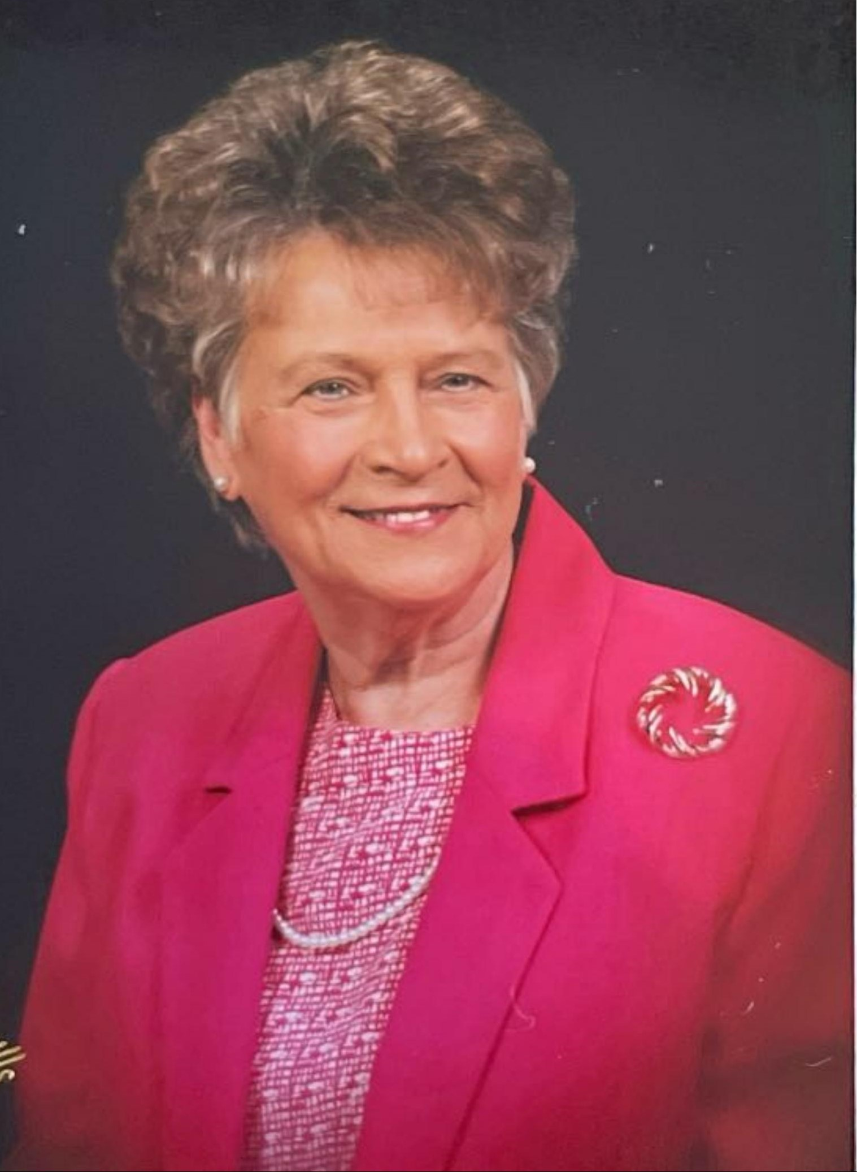
Shirley Maude McMichael Miller, age 89, passed away Monday, November 25, 2024 at her home in Monticello, surrounded by her loving family.

Shirley Miller was born and raised in Monticello to the late Seaborn McMichael and Lucille Stone McMichael. She started her school years at the Old Piedmont School House and graduated from Monticello High School. During her school years, she worked at the local Royal Theatre stubbing and selling tickets, popping popcorn and selling candy. After graduation in 1953, she moved to Atlanta to live with her two aunts and worked for Park Davis Drug Company as their youngest secretary. A country girl at heart, she never liked living in Atlanta and came home every weekend and cried when she would have to return to Atlanta.

She married Harvey Miller on March 27, 1953 and worked for a couple of years at the Chevrolet Dealership as office manager. In 1957, she went to work for the Feldspar Corporation and retired after forty-two years as office manager. She was blessed to work beside her two sisters, Margie Sauls and Jean Manville during her years at Feldspar.

She and her late husband, Harvey built the home on Hilton Street in 1963 and lived there until her passing. She and Harvey were master gardeners with their roses. She continued growing and sharing her roses even after his death on April 22, 1997. After retirement, she kept busy with yard work, housekeeping, cooking and spending time with family and friends. She was quite famous for her delicious cakes, chocolate meringue pie, homemade pimento cheese sandwiches, divinity and cornbread.

In addition to her parents and husband, she was preceded in death by her great-granddaughter, Kate Miller and sister, Jean McMichael Manville.

She is survived by her sons, Tom (Joanne) Miller of Monticello, Jerry (Vera) Miller of Loganville and daughter, Tammy (Mike) Welch of Monticello; grandchildren, John (Beth) Miller, Thomas (Natalie) Miller, Cegi (Joseph) Laudicina, Kayla Miller and Ali (Austin) Key; great-grandchildren, Grant (Mallory) Miller, Jackson Miller, Charlie Miller, McKinlee Laudicina and Cheyanne Laudicina; sisters, Margie Sauls of Monticello and Patricia Griffin of Warner Robins and brother, Jimmy (Lynda Sue) McMichael of Monticello; sisters-in-law, Martha Miller and Eleanor Sue Reeves; numerous nieces and nephews; and special friends, Evelyn Moore and Gertrude Ozburn.

Funeral services will be held at 11:00 A.M., Saturday, November 30, 2024, at the Monticello Baptist Church. Interment will be held in West View Cemetery. Rev. David Artessa will officiate.

The family will receive friends from 5:00 P.M. until 7:00 P.M., Friday, November 29, 2024, at Jordan Funeral Home.

Serving as pallbearers will be Jay McMichael, Greg McMichael, Ricky Griffin, Grant Miller, John Miller, Thomas Miller, Tony Manville and Gary Scroggs. Honorary pallbearers will be Joe McMichael, Mike Manville, Caleb Sauls, Phillip Manville, Garrett Scroggs, Walt McMichael, Brady McMichael, Clay Evans, Ben Manville, T. J. Sauls and Christopher Manville.

The family suggests in lieu of flowers donations be made to the Monticello Baptist Church, 334 W. Greene Street, Monticello, Georgia 31064; or Abbey Hospice 215 Azalea Court, Social Circle, Georgia 30025; or St. Jude Children’s Research Hospital; (stjude.org/donate).

Jordan Funeral Home is in charge of arrangements.

