**Jordan Funeral Home, Inc.**

**PO Box 46**

**Monticello, Georgia 31064**

**706-468-6303**

**Fax: 706-468-2205**

**Email:** [**jordanfh@bellsouth.net**](mailto:jordanfh@bellsouth.net)

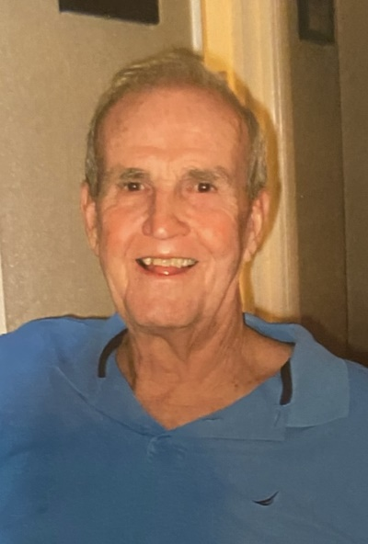Larry Persons Lynch of Shady Dale, Georgia passed away on Sunday, September 22, 2024, at the age of 87. Larry was born on May 5, 1937 in Jacksonville, Florida, to Hal Lancaster Lynch, Sr. and Finney Persons Lynch who were originally from Putnam County and Jasper County, respectively.

Larry was educated in the public schools of Duval County and graduated from his beloved Lee High School. He next attended Baylor University in Waco, Texas, with which he had a life-long love affair. He grew up worshipping at Riverside Baptist in Jacksonville where he met the love of his life, Nancy Matthews, to whom he was married for 60 years.

After graduating from Baylor, Larry worked in the family automotive business; he remained active in that business until the end of his life. At the age of thirty-one, Larry moved his family from Jacksonville to Monticello to return to his roots. He then pursued a law degree at Mercer University and went on to become a country lawyer. He had a stellar reputation and developed lifelong friendships with colleagues and clients.

Larry was passionate about many things, but was most passionate about Shadydale Farm, his cattle operation he owned together with his brother, Hal Jr. He loved the land, the cattle, and all things associated with them.

Larry loved Jasper County and Monticello; he spent countless hours serving in various civic organizations and served both on the local school board and hospital board. He was a tireless advocate of the Jasper County Mentor Program which he and Nancy started. And, until the very end, he was an avid Monticello Hurricane fan. There are countless former football players who still hear in their sleep his yelling “block somebody” from the stands; basketball players who hear “rebound”; and baseball pitchers who hear “throw a strike”.

Larry loved Monticello Baptist Church; he taught Sunday school there for over fifty years during which he filled countless yellow legal pads with his notes. He loved the Lord with his whole heart; it was the most important thing in his life.

Larry is survived by his wife, Nancy; brother, Hal Lynch, Jr. of Jacksonville, Florida; sons Tom Lynch (Gretchen) of Jacksonville, Florida, and Jim (Erin) Lynch of Shady Dale, Georgia; daughter Betsy (Buddy) Cain of Monticello, Georgia; grandchildren Abigail Lynch, Henry Lynch, Emmett Lynch (Kelly), Braden Lynch, Ben Lynch, Ethan Lynch, Chad Cain (Marley), Jeff Cain (Lauren), and Matt Cain; and numerous nieces and nephews. His first great-grandchild is expected in November.

Funeral services will be held at 2:00 P.M., Saturday, September 28, 2024, at the Monticello Baptist Church. Interment will be held in Providence Baptist Church Cemetery. Rev. David Artessa and Dr. Bob Whitmire will officiate.

Visitation will be held from 5:00 P.M. until 8:00 P.M., Friday, September 27, 2024, at the Monticello Baptist Church Fellowship Hall.

Serving as pallbearers will be Chad Cain, Jeff Cain, Matt Cain, Ben Lynch, Braden Lynch, Emmett Lynch, Ethan Lynch and Henry Lynch.

In lieu of flowers, the family requests that contributions be made to Monticello Baptist Church Building Fund 334 W. Greene Street, Monticello, Georgia 31064; or to Jasper Memorial Hospital 898 College Street, Monticello, Georgia 31064.

Jordan Funeral Home is in charge of arrangements.