Jordan Funeral Home, Inc.
PO Box 46
Monticello, Georgia 31064
706-468-6303
Fax: 706-468-2205
Email: jordanfh@bellsouth.net

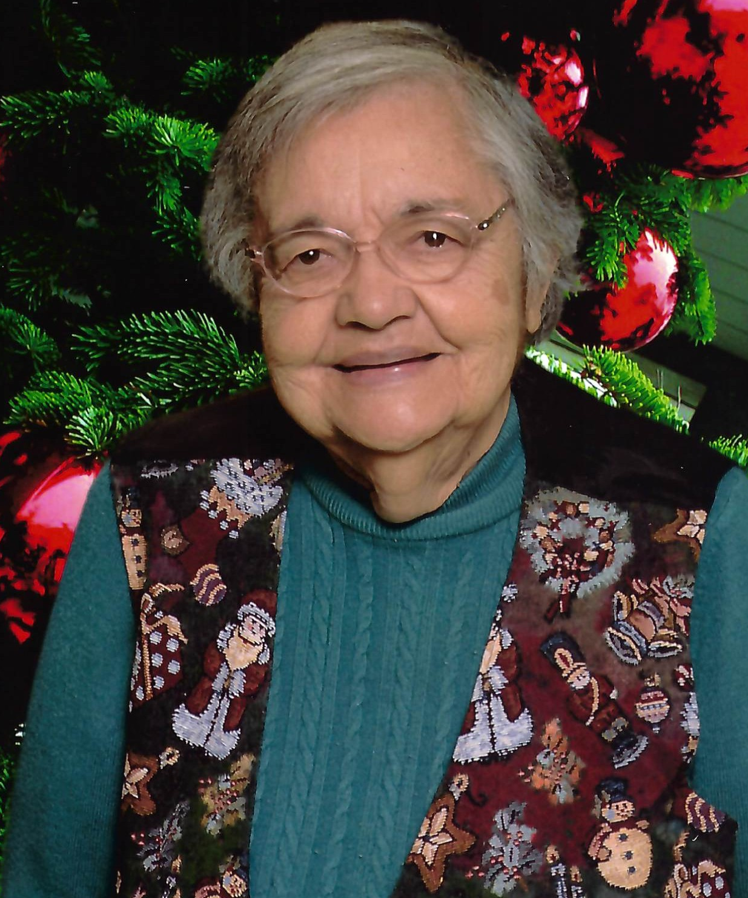
Gail Benita “Patsy” Vigil Evans, age 83, passed away Sunday, February 16, 2025.
Patsy Evans was born on August 10, 1941, in Alamosa, Colorado to the late Delfino Vigil and Sara Quintana Vigil. She married the late Robert Lefton Evans on June 18, 1960. He passed away in 1992.

Patsy Evans was an active member of New Rocky Creek Baptist Church. She was a member of the WMU and they enjoyed serving meals at the Police Department, Fire Department; and serving snacks for teacher’s appreciation at the beginning of the school season.

Patsy Evans enjoyed cooking for people and even won numerous events during the Venison Cook-off at the Jasper County Deer Festival. She was famous for her chili and other Mexican dishes she served. She enjoyed picking up and shelling pecans and mailing to family members in New Mexico.

In addition to her parents and husband, she was preceded in death by her siblings, Virginia Blea, Doris Ruybal, Gilbert Vigil, Francis Blea, Joseph Blea, Delfino Vigil, Jr. and Mary Ann Martinez.

She is survived by her children, Lynn (Wendell) Pope of Monticello, Tim (Susan) Evans of Monticello, Chris (Alice) Evans of Monticello and Linda (Kurt) Neff of Ellijay; grandchildren, Shannon Evans, Clint Bergeron, Keri Evans, Kristen (Mark) Pierce, Clay Evans, Amanda (William) Cooper, Morgan (Justin) Armour, Carlie (Nick) Hulburt, Mac (Peyton) Harwood, Rileigh (Chandler) Burrell, Baylee (Gage) Knight, Jimmy (Amanda) McCaleb, Ronny McCaleb, Kristina Brooks, Sarah Pickens, Caitlyn (Jason) Barbone and Emily Neff; twenty-two great-grandchildren; sisters, Henrietta Gallegos, Helen Vigil, Yolanda Roybal; brother, Phillip Blea; and numerous nieces and nephews.

Funeral services will be held at 11:00 A.M., Friday, February 21, 2025, at New Rocky Creek Baptist Church. Interment will be held in West View Cemetery. Dr. Randal Reese will officiate.

Serving as pallbearers will be Clay Evans, Clint Bergeron, Ronny McCaleb, Mark Pierce, Rileigh Burrell and George Deraney.

The family will receive friends from 5:00 P.M. until 7:00 P.M., Thursday, February 20, 2025, at Jordan Funeral Home.

The family suggests in lieu of flowers donations be made to Peaceful Purpose Hospice 106A N. Jefferson Avenue, Eatonton, Georgia 31024.

Jordan Funeral Home is in charge of arrangements.

