Jordan Funeral Home, Inc.
PO Box 46
Monticello, Georgia 31064
706-468-6303
Fax: 706-468-2205
Email: jordanfh@bellsouth.net

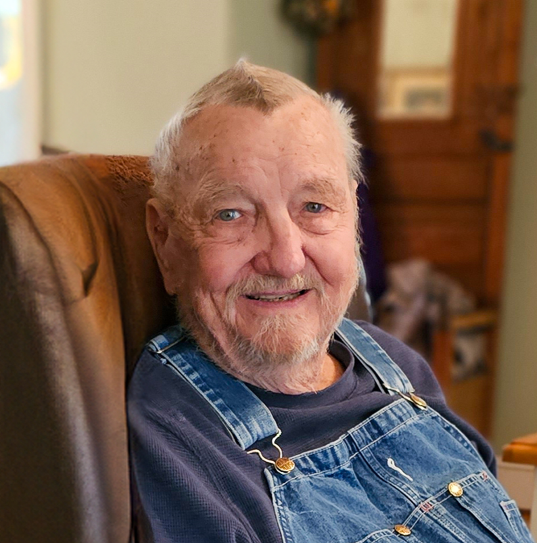

Hoyt “Billy” Dunn, master craftsman, carpenter, prankster, and overall fix it man, passed away on the morning of Saturday, August 17, 2024.

Born November 27, 1937, in Dekalb County, he later graduated from Stone Mountain High School and married Mary Maughon Dunn before working at Custom Craft Upholstery, Maughon Electric Co., maintenance director for the Rockdale County School System, and at Russell Bennett Contracting.

Married to his wife, Mary, of sixty-six years, their legacy includes stewards of the land, and caregivers of family, friends, community and strangers. Together, through food and craft, they volunteered countless hours over the years. Gifted in all trades, he was the master troubleshooter, carver, electrician, upholsterer, and woodworker. He loved his beagles, rabbit hunting, being on a tractor, quiet time on his land, and watching over the flora and fauna of the farm. He also enjoyed watching his grand and great grandchildren play in the yard. A devotee of time spent making, he proudly shared his work with anyone in need. He was our friend, confidant, and a constant in our lives.

Billy is preceded in death by his parents Hubert and Annie Maude Dunn, brother Robert Dunn, sisters Anne Wood Higgins, Ruby Dunn, and Chris Gallman, and daughter Traci Dunn Mitchell. He is survived by his wife Mary Maughon Dunn, children Keith (Kay) Dunn, Angie (Russell) Bennett, son-in-law Brian Mitchell, and grandchildren John Phillip (Jennifer) Dunn, Candice (Scott) Nanney, Clint Dunn, Brandon (Betony) Bennett, Jackson Mitchell, and Regan Mitchell. Great grandchildren include Chase and Lane Dunn, Brynley, Bristol, and Brenna Bennett, and Katie, Bennett, and Cameron Nanney.

Visitation will be held at Jordan Funeral Home on Monday, August 19 from 4:00 to 8:00 pm. Funeral service will be held Tuesday, August 20, 11:00 am at Monticello Baptist Church officiated by Rev. Wes Tanner and son, Keith Dunn. Interment will be held in West View Cemetery.

Serving as pallbearers will be John Phillip Dunn, Clint Dunn, Brandon Bennett, Scott Nanney, Zach Snope, Chase Dunn and Lane Dunn.

The family has requested donations be made to your local church or charity of choice in lieu of flowers.

Jordan Funeral Home is in charge of arrangements.

