Jordan Funeral Home, Inc.
PO Box 46
Monticello, Georgia 31064
706-468-6303
Fax: 706-468-2205
Email: jordanfh@bellsouth.net
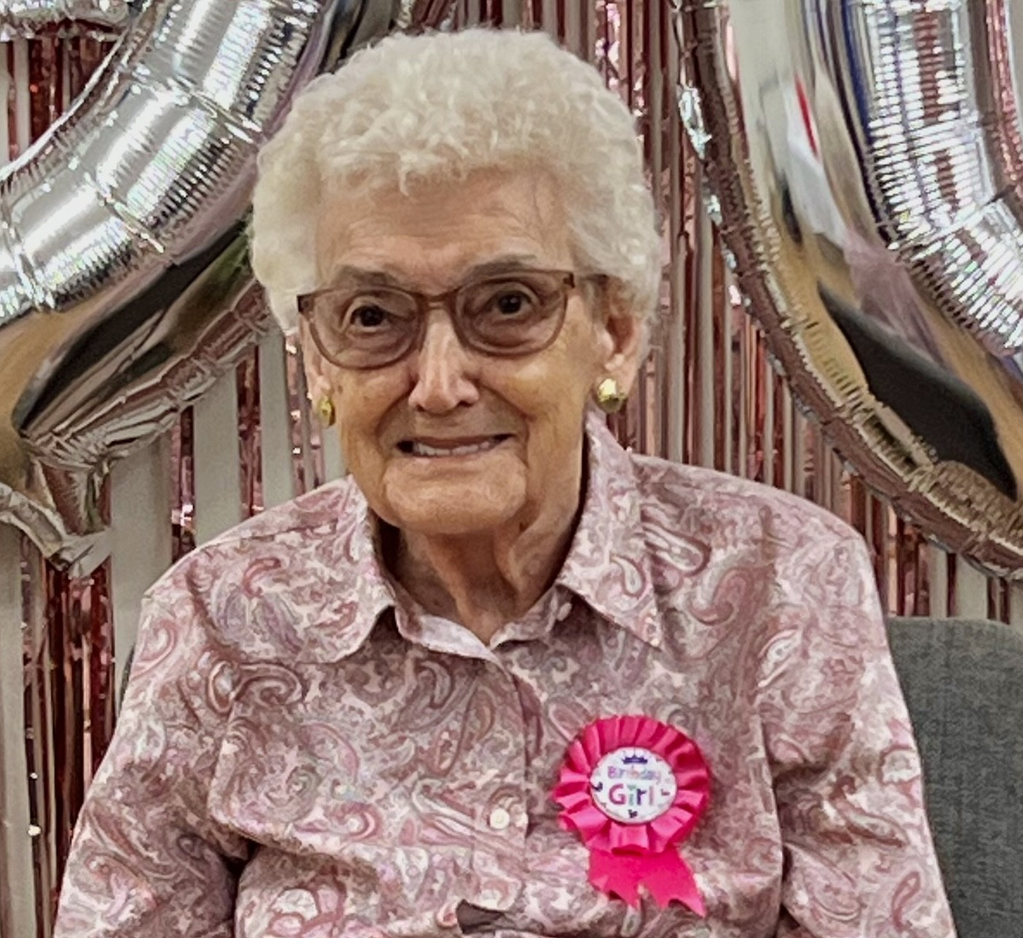
Willa Dale Hylemon Boone, 90, passed away Sunday, April 6, 2025, at Abbey Hospice in Social Circle, Georgia

Willa Dale Boone was born on October 6, 1934, in Burnsville, North Carolina to the late Abe Hylemon and Myra Phillips Hylemon. From the time she was a young girl she loved the outdoors and the simple life of living in the mountains. She never deviated from that mindset. She married the late Rudolph Harvie Boone on June 6, 1953, a union of sixty-three years. They moved to Monticello in 1959.

Willa Dale Boone worked as a bank teller for the Farmer’s National Bank; later, she worked as a store clerk for the Red & White Grocery Store in Monticello. Before retirement, she worked as a manager for both the Magic Market and Oxford Industries in Monticello. She was known for her kind and helpful spirit. She was loved by her coworkers and customers.

She was a dedicated wife and mother that loved her family intensely. She loved the Lord with all her heart and that was clearly seen in her actions. She treated everyone with kindness and respect. She enjoyed reading her Bible, cooking, gardening, flowers, watching her bird feeders, afternoon golf cart rides, trips to Walmart, daily phone calls with her precious sister in North Carolina, visits from family and friends, and especially snacks and candy. She attended Enon Baptist Church.

In addition to her husband and parents, she was preceded in death by her brother, Robert Hylemon.

She is survived by her children, Deborah “Debbie” Hooper (Robert) Carden, Karen (Doug) Morgan, Denise (Robbie) Pulliam and Tony Boone of Monticello; grandchildren, Donnie (Johnna) Pope, Justin (Nicole) Hooper, Toni (Michael) Ward, Josh (Katie) Boone, Dusty (Rachel) Boone, Emily Boone, Gage Boone, Sammie Dee Denny, Michael “Bubba” (Brittany) Tillman, Keith (Jennifer) Pulliam and Mandi (Louis) Maurino; numerous great-grandchildren; sister, Erelena Hughes of Burnsville, North Carolina; sister-in-law, Winona Covington of Covington; and numerous nieces and nephews.

Funeral services will be held at 11:00 A.M., Tuesday, April 8, 2025, at the Chapel of Jordan Funeral Home. Interment will be held in Hebron Cemetery. Donnie Pope will officiate.

Serving as pallbearers will be her grandsons, Justin Hooper, Michael Tillman, Keith Pulliam, Josh Boone, Dusty Boone and Gage Boone.

The family will receive friends from 5:00 P.M. until 7:00 P.M., Monday, April 7, 2025, at Jordan Funeral Home.

Jordan Funeral Home is in charge of arrangements.

